**Create a calculator to work with rational numbers.**

**Requirements:**

**➢ It should provide capability to add, subtract, divide and multiply rational Numbers**

**➢ Create a method to compute GCD (this will come in handy during operations on**

**rational)**

**Add option to work with whole numbers which are also rational numbers i.e. (n/1)**

**➢ achieve the above using auxiliary constructors**

**➢ enable method overloading to enable each function to work with numbers and**

**rational.**

**Basic Add for Rational Numbers:**

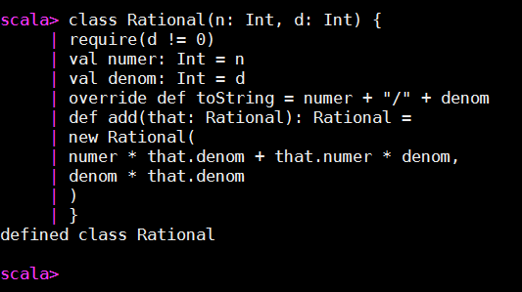

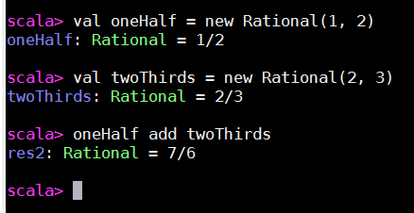

**GCD With Auxiliary Constructor:**

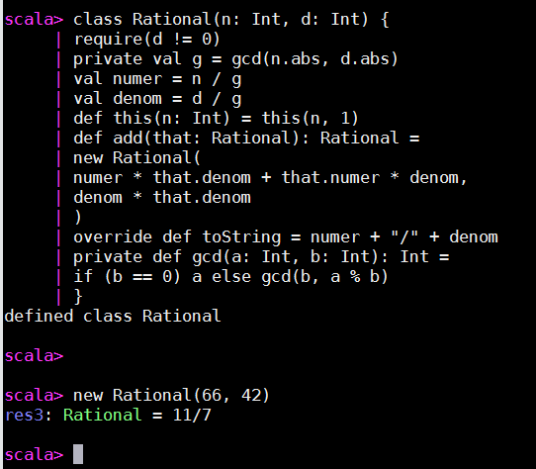

**GCD with Overload:**

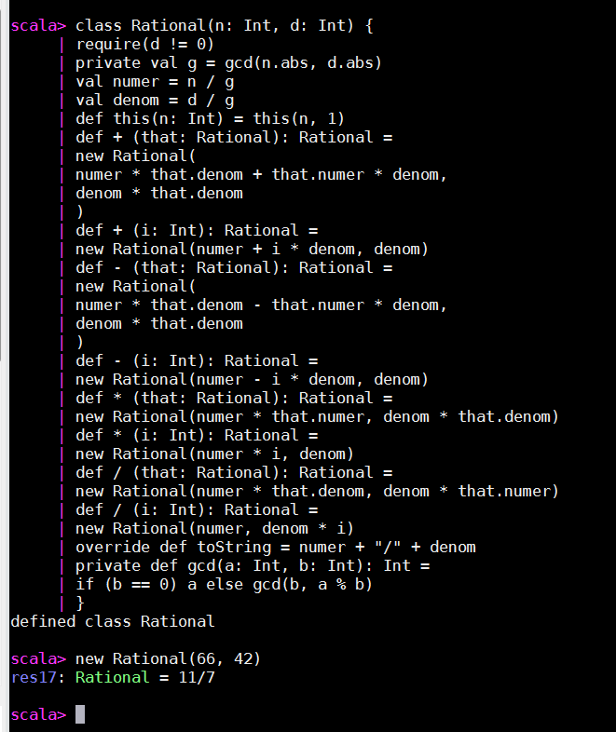

**ADD, SUBTRACT,MULTIPLY AND DEVIDE RATIONAL NUMBERS:**

**Using Auxiliary Constructor we are doing Add and Multiply:**

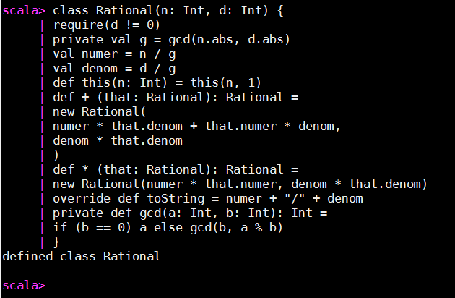

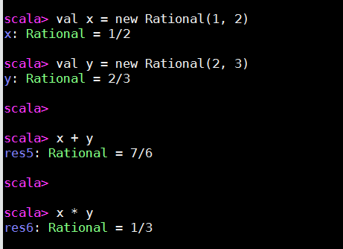

Using Overload and Auxiliary constructor for Add Multiple, Divide and subtract:

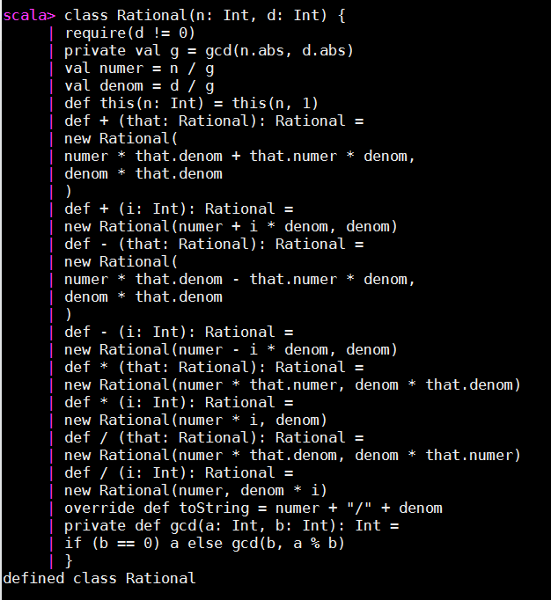

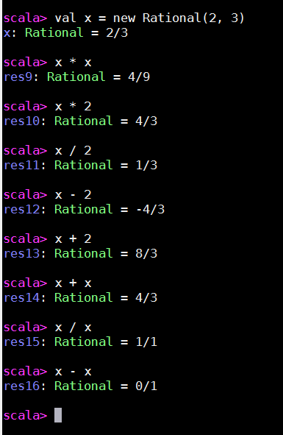

**WHOLE Numbers use as Rational Numbers:**

